Citizenship, Economics and Society (Secondary 1-3)
“3-minute Concept” Animated Video Clips Series:
“Smart City”
Teaching Guidelines

1. Title of the animated video clip: “Smart City”
2. Duration of the animated video clip: Around 3 minutes
3. Related CES Module: Module 2.4 Economic Performance and Human Resources of Hong Kong
4. Introduction of the animated video clip: : The animated video clip was developed by the Personal, Social and Humanities Education Section, Curriculum Development Institute, Education Bureau. It uses daily examples and simple language to succinctly explain the concept of “Smart City”.
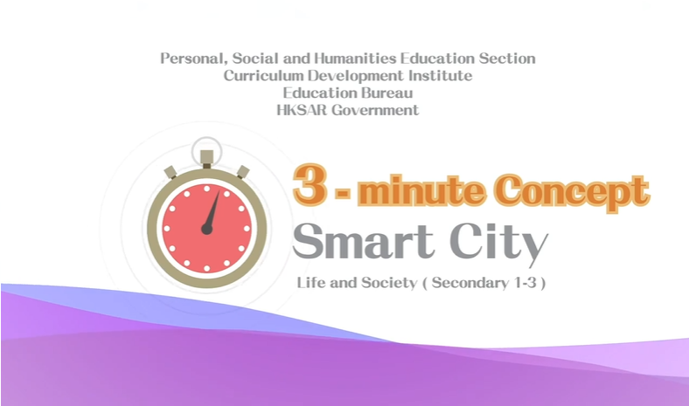
Citizenship, Economics and Society
(Secondary 1-3)
Video link:
https://emm.edcity.hk/media/Life+and+Society+%223-minute+Concept%22+Animated+Video+Clips+SeriesA+%283%29+Smart+City+%28English+subtitles+available%29/1_fnoxi0io
5. Teaching tips: Teachers must explain the following main points to students after playing the “Smart City” animated video clip:
1) The Government of the Hong Kong Special Administrative Region is actively promoting smart city development | Teachers should point out to students that the Government of the Hong Kong Special Administrative Region has been committed to promoting smart city development in recent years. As early as December 2017, the government released the Smart City Blueprint for Hong Kong, proposing a number of initiatives in six areas, namely “Smart Mobility”, “Smart Living”, “Smart Environment”, “Smart People”, “Smart Government” and “Smart Economy”, such as the introduction of a fast payment system “FPS”, the provision of free public Wi-Fi hotspots and an “iAM Smart” one-stop personalised digital services platform, etc. The Government further released the Smart City Blueprint for Hong Kong 2.0 in December 2020, proposing over 130 initiatives to continue enhancing and expanding existing city management measures and services. The new initiatives aim to bring benefits and convenience to the public so that residents can better perceive the benefits of Smart City and innovation and technology in their daily lives. Examples include applying “Building Information Modelling”, enhancing smart tourism platforms, establishing the LawTech Fund, developing the Traffic Data Analytics System, and implementing Smart Village pilots, etc. For details of the Smart City Blueprint, please refer to the following resource:  Hong Kong Smart City Blueprint - Vision and Mission  https://www.smartcity.gov.hk/vision-and-mission.html
2) Hong Kong has a well-established mechanism to protect the personal data of the public adequately | Teachers should point out to students that Smart City aims to use technology to enhance the effectiveness of city management, improve the people’s quality of life, and create new job opportunities to maintain the vitality and competitiveness of the city. Teachers should further point out to students that using big data technology inevitably requires access to personal data provided by the public. However, Hong Kong already has a comprehensive personal data privacy protection mechanism which fully protects the personal data of its citizens, including establishing the Office of the Privacy Commissioner for Personal Data. The Office of the Privacy Commissioner for Personal Data is an independent body responsible for monitoring, supervising, promoting and enforcing compliance with the provisions of the Personal Data (Privacy) Ordinance (Cap. 486 of the Laws of Hong Kong. For the duties of the Office of the Privacy Commissioner for Personal Data, please refer to the following resource:  Office of the Privacy Commissioner for Personal Data - Our Role  https://www.pcpd.org.hk/english/about_pcpd/our_role/what_we_do.html
3) The cyber world is not without supervision and the use of information technology must comply with the law | Teachers should point out to students that Smart City not only attach importance to the benefits of technology in governance, social and economic development but also the information literacy of the public. Teachers should further point out to students that the cyber world is not a virtual world without supervision. Under the existing laws of Hong Kong, most laws targeting crime prevention in the real world also apply to the cyber world. When using technology, it is important to comply with the law, stay safe online, and protect personal data. For laws targeting computer-related offences, please refer to the following resource:  Hong Kong Police Force - Relevant Legislation on Computer Crimes  https://www.police.gov.hk/ppp_en/04_crime_matters/tcd/legislation.html

6. Consolidation questions: (See next page)

“3-minute Concept” Animated Video Clips Series:

“Smart City”

Worksheet

A. Fill-in-the-blank Questions
Put the correct answers in the spaces provided.
Smart city:

B. True or False
Study the following sentences about “Smart City”. Put a “T” in the blank for correct description and an “F” for incorrect description.
 | Travellers can obtain real-time information through intelligent systems to plan their journeys more effectively. | T
 | The intelligent systems provide real-time information on the consumption of water, electricity and gas, which will allow users to know their energy consumption and help change their habits to reduce waste and pollution. | T
 | Citizens can adapt and use technology to manage their daily lives, such as conducting electronic transactions. | T

C. Matching
Match the six characteristics of “Smart City” in the left column with the possible directions for the development of “smart city” in the right column by putting the letter in the bracket.
Characteristics of “Smart City” |  | Possible directions for the development of  “Smart City”
- Smart Environment | ( E ) | - The data provided by intelligent systems will allow service providers to grasp the overall usage, to manage the system load and to respond to the needs of different periods.
- Smart Mobility | ( F ) | - Citizens can use technology to manage their daily lives, such as conducting electronic transactions.
- Smart Government | ( D ) | - By optimising the business environment, attracting start-ups and investment, promoting smart production and supporting the development of high value-added industries, new employment opportunities will be created.
- Smart Economy | ( B ) | - The real-time information on people, traffic and logistics flow will allow us to better manage traffic flow, priorities for road use, etc.
- Smart Living | ( C ) | - The government opens up public sector data to promote their innovative applications and to improve public services.
- Smart People | ( A ) | - Smart labels on different products enhance the recycling efficiency since automated identification systems can easily identify harmful substances and profitable recyclable materials.

D. Short Question

What are the impacts of “Smart City” on our lives?
“Smart City” increases the efficiency of its resource use, optimises
city management and services,and improves the environment,
which together will improve the quality of life of the citizens.

The End

